November 23, 2015

Nick Theobald: WITH HONEY FROM THE ROCK at Richard Taittinger Gallery
By David A. Clark

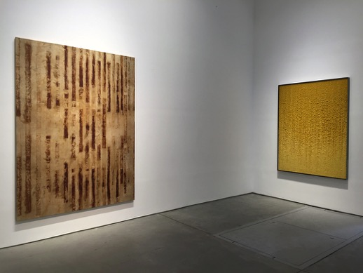
Installation view, WITH HONEY FROM THE ROCK at Richard Taittinger Gallery

There is a particular sensation that comes with rain. Time slows and one’s tactile appreciation of touch, sound and smell is heightened. One luxuriates in that sensation as the perception of time slows with the elongated drumming pause that accompanies the steady fall of liquid from the sky. I felt that sense of suspension while viewing Nick Theobald’s almost reverential solo at Richard Taittinger Gallery on Manhattan’s Lower East Side. The works present in the gallery slow one’s sense of time and bathe the viewer in their tranquil, organic materiality like rain.

More information about Nick Theobald and Richard Taittinger Gallery can be found on their websites below. WITH HONEY FROM THE ROCK runs through December 12th. Richard Taittinger Gallery, 154 Ludlow Street, New York, NY.

http://richardtaittinger.com http://nick-theobald.com
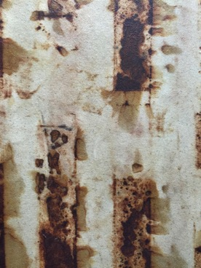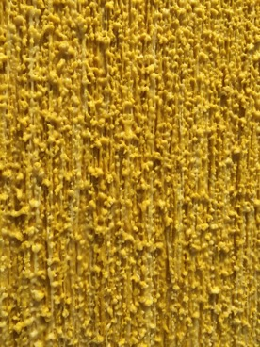
Detail view, Nick Theobald, “Phlogiston Flow”, 2015
Detail view, Nick Theobald, “Resonance”, 2015

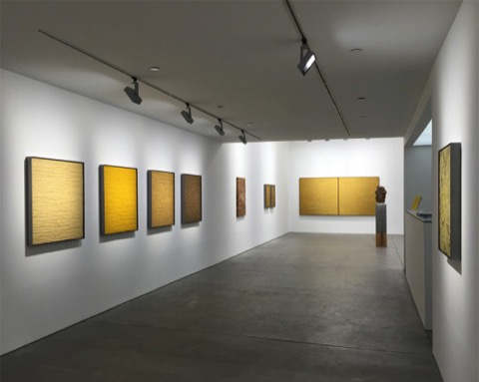
Installation view, WITH HONEY FROM THE ROCK at Richard Taittinger Gallery

