April 8, 2016

The Week in Art: Tribeca Ball and MoMA PS1 Open House

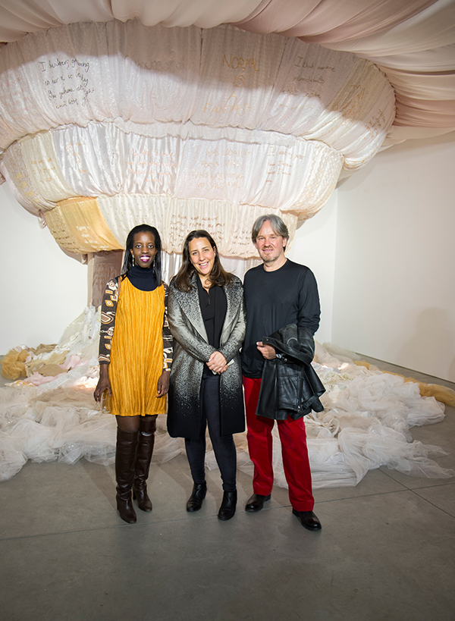
Siima Itabaaza, 1:54 Contemporary African Art Fair director Touria El Glaoui, and Gary Van Wyk from Axis Gallery at the celebration of 1:54 FORUM at Richard Taittinger Gallery.
Photo: courtesy 1:54 Contemporary African Art Fair.

Though it may seem that Armory Week and Frieze Week get all the action, the reality is that there is never a dull moment in the New York art world. From the East Side to the West Side, there’s always something happening at the city’s museums, galleries, and various event spaces. This week was no exception.

1:54 Contemporary African Art Fair Celebration of 1:54 FORUM at Richard Taittinger Gallery
As 1:54 Contemporary African Art Fair prepares returns to Pioneer Works for Frieze Week (May 5-8), the fair, now in its second edition, announced the details for 1:54 FORUM, with a cocktail event at Richard Taittinger on April 7. Frances Goodman’s current solo exhibition “Rapaciously Yours,” provided a dramatic backdrop to the festivities, particularly with her large-scale installation, The Dream, made from discarded wedding dresses.

Fair director Touria El Glaoui introduced FORUM curator Koyo Kouoh, of EVA International 2016 (Ireland’s Biennial) and RAW Material Company in Dakar, who has an impressive team on board for this year’s programming: Adrienne Edwards (Performa, New York and Walker Art Center, Minneapolis), Ugochukwu-Smooth C. Nzewi (Hood Museum of Art, Dartmouth College), and independent New York-based curator Dexter Wimberly.

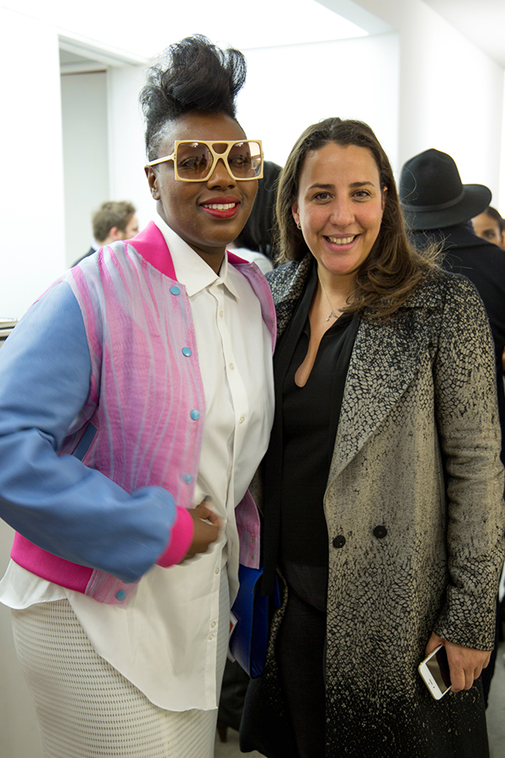
1:54 Contemporary African Art Fair director Touria El Glaoui (right) at the celebration of 1:54 FORUM at Richard Taittinger Gallery.
Photo: courtesy 1:54 Contemporary African Art Fair.

